Training Course – Handling Difficult Customers

No organisation will always get it right and so an inevitable part of the job is dealing with customers who have been upset or disappointed with our service.

Because of the emotion involved these customers can be challenging. Our role as advisers is to focus on solving the problem in a calm and professional way.

Be part of the solution, not part of the problem.

The first area is to allow the customer to vent their feelings. It is unreasonable and inappropriate for us to interrupt a customer and ask them to “calm down” when they may have been trying to solve this problem for days!

Pause

Allows the customer to express themselves and vent their emotion. Anything we say at this point will only serve to fan the flames.

Acknowledge

This is our chance to show empathy and to demonstrate that we are taking the customer seriously.

Clarify

We need to understand the detail to make sure that we fully understand the issues. We need to do this with tact and patience. It is also worth explaining to the customer why you need to ask these extra questions. Remember the customer may have explained this before!

Respond

Having diffused the emotion, taken the issue seriously and understood the detail, now we are ready to respond. Our response needs to be positive and appropriate. We also need to ensure that we are not over promising. If you say you’re going to do something ensure you do it-or you will have a really difficult customer to deal with.

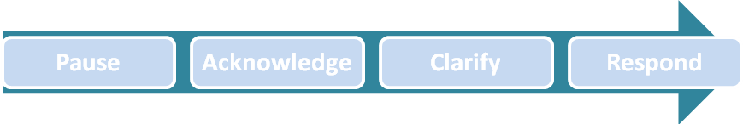

Focus on what we can do

Customers have little or no interest in your company policy and nor is it a good use of anyone’s time to explain what we can’t do for them. Instead explain what we are able to do and try to present this as a choice for the customer.

Tone

Use a tone that conveys that you are taking the customer’s issue seriously, but then try adjusting it gradually so when you are presenting the solution options you are upbeat and positive. Good news delivered in the wrong tone will still sound like bad news!

In their shoes

You probably got into customer service, because you like people. Use your communication skills to understand the problem and user your natural empathy to step into the customer’s shoes. Your actions at this part of the customer journey have a massive impact on their regard for the company.

Creating a L.A.S.Ting impression

A simple way to approach a customer issue large or small is to take the L.A.S.T approach.

LISTEN
APOLOGISE
SOLVE
THANK

Listen
An angry customer will have been thinking for some time about what they are going to say when they get through. They may have mentally rehearsed it too. The last thing they will want is an interruption.

It is vital that we really listen though as this customer will not appreciate having to repeat themselves. So allow them to explain what has happened and listen hard to get the details.

Apologise
We are not accepting any liability when we apologise, but we are expressing our sympathy that someone is upset. It needs to be sincere and well timed

E.g-I am sorry you have had that experience

Solve
There are several parts to this phase. Firstly we need to be sure of the root-cause. This will need effective questioning with your funnel. When we are sure of the issue we present possible solutions. The presentation of this is key and we need to consider how we’d like the customer to feel.

We want the customer to feel | We don’t want the customer to feel
Reassured  They have been listened to  We care  Impressed with our handling of the issue | No trust  Fobbed off  They don’t matter  Even more disappointed

To achieve these emotions we need to present a solution that meets their needs and offers flexibility which is why it often works to present choices.

E.g-We can send the replacement to you within the next 48 hours, or you could collect it from your local store tomorrow. Which is best for you?

Thank

This is our opportunity to thank the customer for a couple of things.

- Giving us a chance to fix their problem
- Bringing it to our attention
- Their patience

Just like the apology we need to be sincere and appropriate. There is an opportunity to impress the customer if this part comes in a follow up call.

E.g- I am just calling to check that everything is now sorted and can I just thank you for your patience in this.

Be Professional

In all this as with any customer situation our emotions need to be managed. If we respond with emotion, even if it’s juts defensive then the situation will escalate. We must choose our attitude and empathise with the customer.

Remember they are angry with the company when. We decide if we are part of the problem or part of the solution in choosing our reaction to the call.

Key Learnings

- Allow a customer to vent their frustration
- Really listen to them and seek clarity where necessary
- Never react with emotion
- Choose your attitude
- Be sincere and authentic
- Present solutions in a positive way
- Give customers choice
- Always follow through.

This has kindly been supplied by Rob Wilkinson

More courses available here https://www.callcentrehelper.com/tag/cheat-sheet

